**Assignment One**

# **Academic research paper - Legal and Ethical**

**Prepared by: -**

Vrajesh Choksi – 21801861

**Program Tutor: -**

Scott Morton **&** Simon Dixon

### 

**Information Technology Studies**

The Information Technology Environment

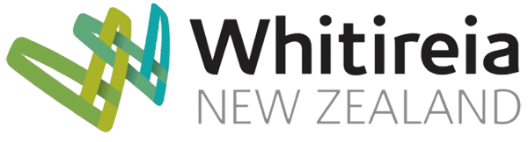

# **INTRODUCTION: -**

Starting a new IT business can be thrilling and scary. There are many operative things we need to keep in mind before starting a business. It includes the size of the business, location, Worker, etc. Apart from these we had to also acquire knowledge about the Taxes, Securities Regulations, Workers Compensation, how would be the structure, Ownership type, Ethical Behaviour and many more. So before starting an IT business we had to look all this factor, so in this report we will discuss about how we can set up an IT business with all the factors and concerns.

This is a report of small IT company which I am thinking to start up with the sole proprietorship which will be owned & operated by an induvial only with the name of SPECTRUM.com. The Business location would be in Tawa (New Zealand). The Approximate start up investment thinking off to be $1,00,000 which initially amount will be taking a loan from the bank & personal savings. The nature of Business type would be of E-commerce and it is intended to operate for online sales.

## Management Structure: -

For Managing Company, it would be a team of employee who will look for the company progress and develop with their ideas into actions. web developer, Product Designer, marketing executive, and outsourcing. In which each person will assign a work.A close up of a logo

Description generated with very high confidence

*Figure 1.1: -* Management Structure: - (Source: - made by me)

## 

# **Ownership Types: -**

In New Zealand there are many different types of ownership which we need to look before opening a company. As we will focus on major ones That is,

1. Sole Trader
2. Partnership
3. Company incorporated (Company Act 1993)

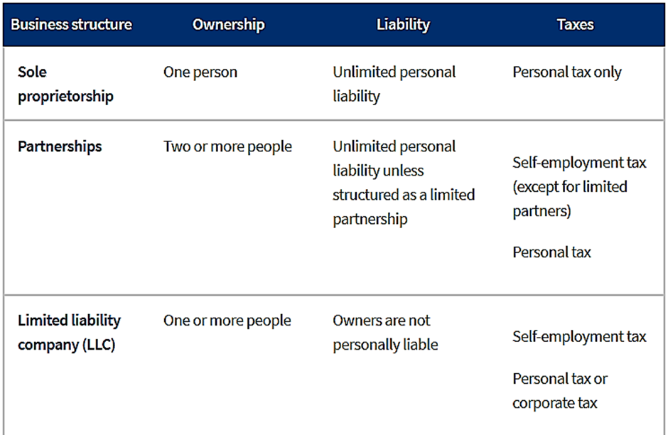

## *Figure1.2: -* Brief Ownership Structure

( Source : -

“ <https://www.sba.gov/business-guide/launch-your-business/choose-business-structure>” )

# **Sole Trader: -**

* It comes under whomsoever is going to open a company on an individual basis by him or herself.
* Many small businesses, self-employed, contractor people begin as a sole trader, as due to its easiest and cheapest option.

*Table No. 1 .1* Pros & cons of Sole Trader*.*

|  |  |
| --- | --- |
| Advantage | Disadvantage |
| * The advantage of choosing is its liberty from government juration and limitation. * Owner has the rights to follow which structure to set up. | * Disadvantage give less capital to company and finical resources. * Holidays can’t be taken easily. |

# **Partnership: -**

* When Two or more people or organisation forms a business is called partnership.
* Partners set out in a partnership agreement how they’ll share profit, debts and work.
* It’s a popular Structure with professionals like Accountants, Lawyers and Architects.
* partnership firm doesn’t require to pay income tax as a business. They divided the income between both and then they the income tax of their share.

## *Table No. 1.2* Pros & cons of partnership: -

|  |  |
| --- | --- |
| Advantage | Disadvantage |
| * Shares the load of running business work. | * Conflicts may arise from difference of opinion from unequal effort. |
| * Partners can bring in more capital investment. | * We might liable for partners business debt. |

# **Company incorporated (Company Act 1993): -**

* A company, in a legal sense, is separated from the people who own it or its directors and shareholders.
* Shareholders are responsible for paying the debts of company if it is in loss as if company is in profit shareholder can gain dividends.

## *Table No. 1.3* pros & cons of Company Incorporated.

|  |  |
| --- | --- |
| Advantage | Disadvantage |
| * Tax Rate will lower than top induvial rate. * To get fund or investment its easy. | * Company needs a lot of capital to grow. * More rules and regulation rather than sole & Partnership firm. |

# **Best Ownership Option: -**

The most suitable ownership for start-up business would be a Sole Trade. As According to few points like,

* As on individually we can invest a small budget first and then slowly, gradually we can increase our Price and Quantity.
* We can take our own decision no another person holds right to take decision.
* As in future we are not forced to sell our company, if we are on progressive track.
* As it’s an induvial owner so there would be a negligible chance for company to go in large costs, debts or loans.
* The Structure would be simple & Cost effective to start up, run and close.
* Tax is also lower whatever you are making profit on that you must pay.

# **Ethical Behaviour: -**

Ethical behaviour is defined by Honesty, Respect, Rights and Equity.

## Importance: -

* It brings transparency in business.
* Cheating with clients would be lower.
* Company will be responsible for the goods and services provided by them to customer whether it would be of replace or repair.
* Employee would be committed of doing right, good and in a proper manner.
* Reputation in business circle would increase by following ethical.

A screenshot of a cell phone

Description generated with very high confidence

### *Figure 1.3:* - Index of Ethical Behaviour of 26 Countries.

(Source: - Dr. Suheela. Redefing Economics from Ethical Perspective October 2017.1 to 7 page “ [www.jetir.org/papers/JETIR1710012.pdf](http://www.jetir.org/papers/JETIR1710012.pdf) ”)

# **Comparing IITP NZ Code with India: -**

## *Table 1.4* Comparing Codes of Ethics New Zealand & India.

|  |  |
| --- | --- |
| IITP New Zealand Code: - | IT Code of India: - |
| * Code Comprises of 8 Tenets. * Tenets are based on Good faith, Integrity, Skills, etc. * Codes are based on Competence, Truth, and Justice. * Ethics Board can dismissal complaint by ¾ majority vote and further deliberate to be fruitless. * No Appeal may be made against the penalty. * IITP can be refer a matter to police or other law enforcement agency. | * Code comprises of 11 tenets. * Tenets are based on Fair Complexion, Equality, Transparency. * Codes are based on Truth, Peoples right, Integrity. * No complaints can be dismissing, it requires to solve. * Appeal can be made against, if it’s a true and unless provided with evidence. * Same as IITP NZ police or Agency can refer to. |

# **Similarity between IITP code of Ethics: -**

## Transparency in Business Standard: -

As we look closer to both country IT codes transparency in business comes out to be a common Code so as we look, the term “Transparency” indicates to accountability, openness and communication. It’s a Metaphorical branch of “Transparent “which means everybody can be able to see direct. In According to upgrade the business or be a successful transparency is must, one should not hide his profit in accordance to pay tax, maintain accounts fairly. One should not keep customers in dark. That means a transparency in Business in a real manner.

## How It would be applied to IT business: -

Transparency is top most Priority for any business, entrepreneurs should be informative and open with their, performances, goals, and working methods. As we look at E commerce sales now a days many frauds can be found at online shopping, product shown on display is different and they get that it also totally different so, sometimes with the payment also many online websites give vouchers of discount, but customers didn’t get any discount they refuse the voucher by saying any excuse. Particularly in E commerce customer should get the receipt of their purchase but many entrepreneurs don’t give invoice voucher in according to save tax and hide their selling and profits which leads to black money. Like this way there are many fraud cases in business and they don’t maintain transparency due to which ethics code become a major point.

## How it would be incorporated and consider important in my IT Business: -

A close up of a logo

Description generated with high confidence*Figure: 1.4*. Strategy for transparency. Source (made by me).

As to bring transparency I would take help of technology which is online feedback regarding service, whether it is hard to process order, customer representative response, Appling appropriate GST or not and rate of product as well. If there is any problem or a bad feedback comes it should be discussed with whole team and advise them to put all efforts to improve all that factor which customer is facing because customer is king, and we are the servant of them. As well it depends on employer also to hire a right person whether it should not be a wrong person who is involve in wrong activity as it impacts the company very bad. Company meetings, progress report and future and motivate employee not to do ant fraudulent activity and give them appropriate advice if they require.

# **Conclusion: -**

In Summary this report of a small IT company had described about E commerce an online shopping a sole trader in name of spectrum. Com which would deal with online shopping of electronic products like laptop, PC, Repair materials at an affordable price. The products would be stored at a house of that would locate at Tawa, so customer have option whether to pick up from store or home delivery option. Reason for choosing Tawa because land rent and electricity cost would be available at a lower rate. It also represents how a small team of people can manage an IT business by following a manner management structure. In Ethics (Ethical Behaviour) and Its code, we could get to know how we can progress company by grow through that points and gain customer satisfaction as well.

# **References: -**

(January 2014) Start Up Sample Business Plan. Continental Business Plan Consulting. New York. (<https://www.business.govt.nz/choose-business-structure/detail/sole-trader?a1=Just%20one&a2=No&a3=No&p=4&q1=1&q2=2&q3=2&r1=Sole%20trader&r2=Company>)

(June 14, 2017) How Transparency Became a Top Priority for Businesses, and Why You Should Care. Larry Alton (<https://www.entrepreneur.com/article/295739>)

(May 2018) Business Structure Overview. Ministry Of Business Innovation & Employment. : New Zealand Govt (<https://www.business.govt.nz/getting-started/choosing-the-right-business-structure/business-structure-overview>)

(May 2018) Why Sole Trader? Ministry Of Business Innovation & Employment. : New Zealand Govt (<https://www.business.govt.nz/choose-business-structure/detail/sole-trader?a1=Just%20one&a2=No&a3=No&p=4&q1=1&q2=2&q3=2&r1=Sole%20trader&r2=Company>)

(June 2015). Administration, S. table Business Structure. ( “ <https://www.sba.gov/business-guide/launch-your-business/choose-business-structure>”)

(September 2014) *Setting up business*. Illinois: Research Park. (<http://www.researchpark.illinois.edu/sites/default/files/media/Starting%20a%20Business%20in%20Illinois.pdf> )

Slideshow 10 Ownership Structure S2 2017. (Slides no. 3 to 30)

Slideshow 21 Ethics S2 2017. (Slides no. 5,7,8,9,10,11,15,17,27,28)